COMSATS UNIVERSITY ISLAMABAD, LAHORE CAMPUS



EXERCISE NO 2

|  |  |
| --- | --- |
| NAME : | HARIS ALI |
| ROLL NO : | FA24-BBA-068 |
| SUBMITTED TO : | MA’AM MUFEEZA MANZOOR |
| COURSE : | PROGRAMMING |

EXERCISES:

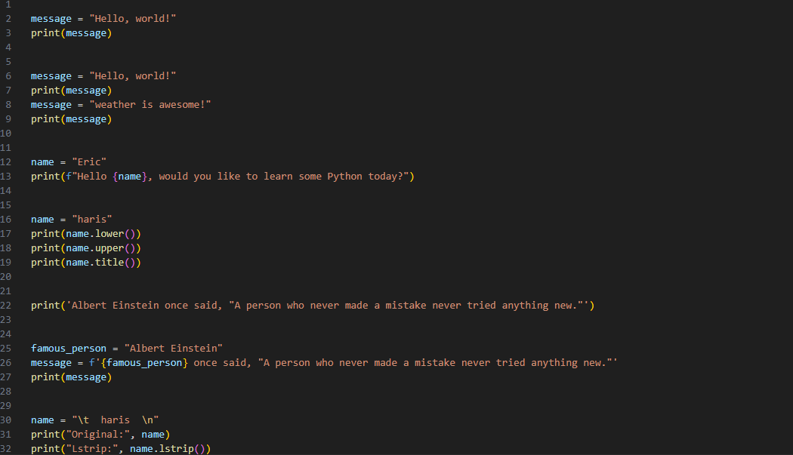

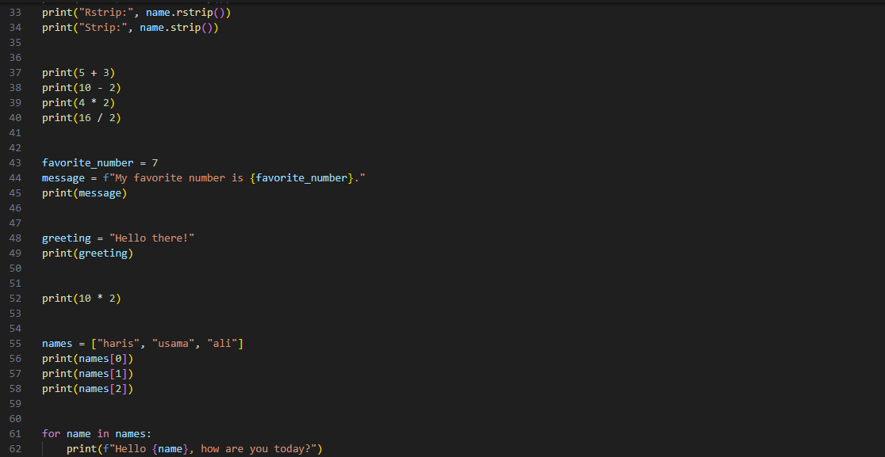

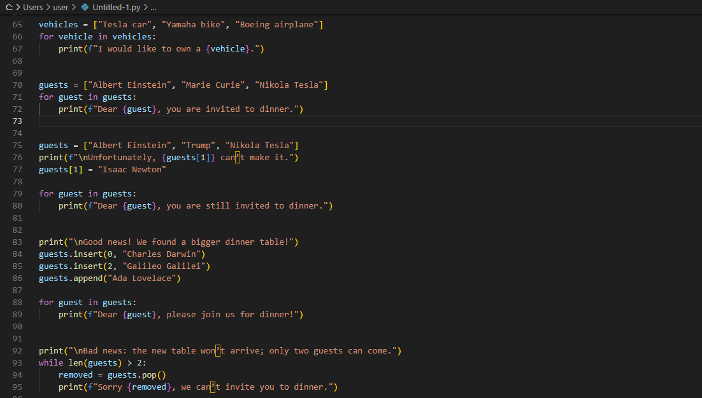

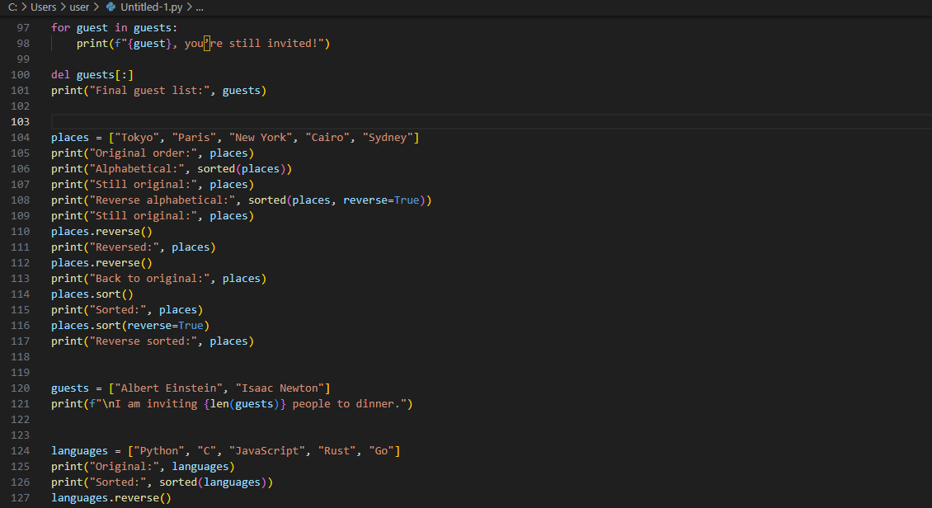

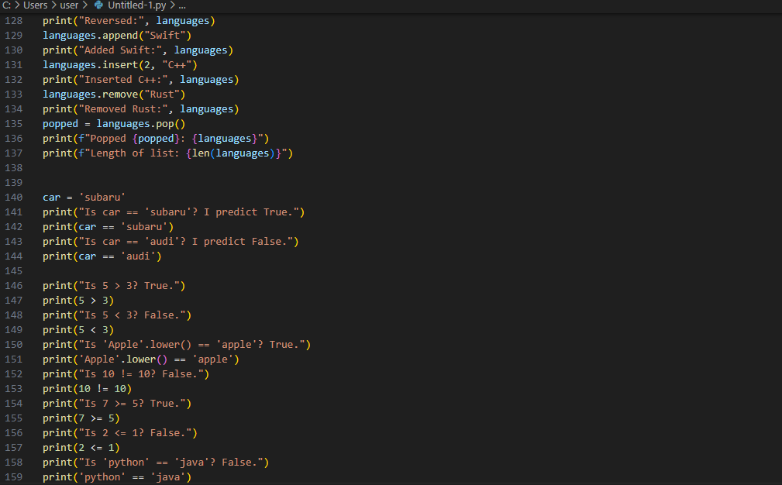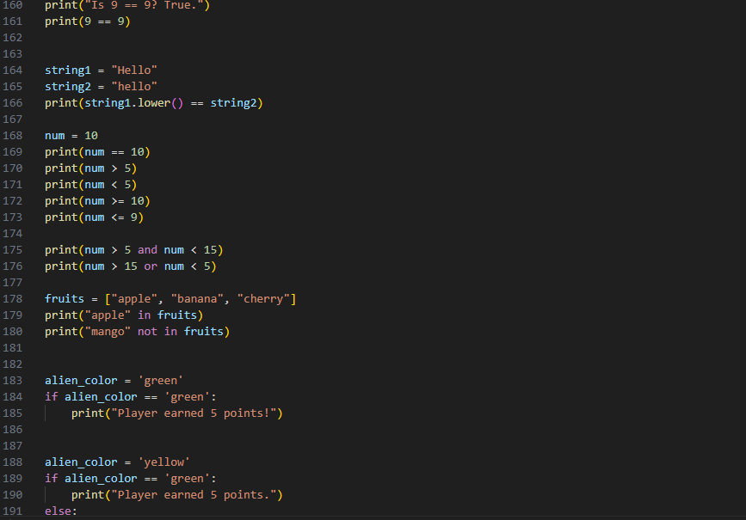

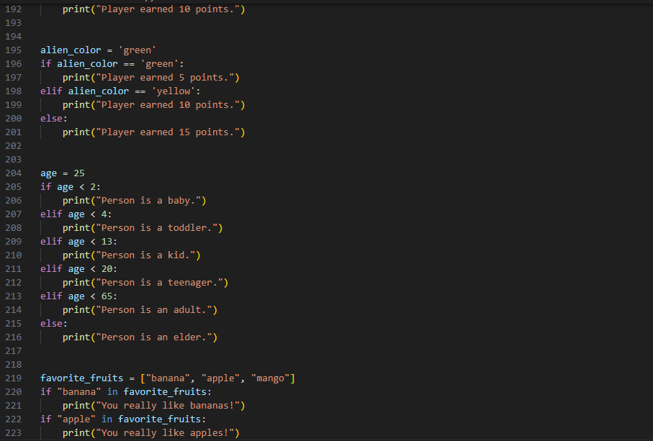

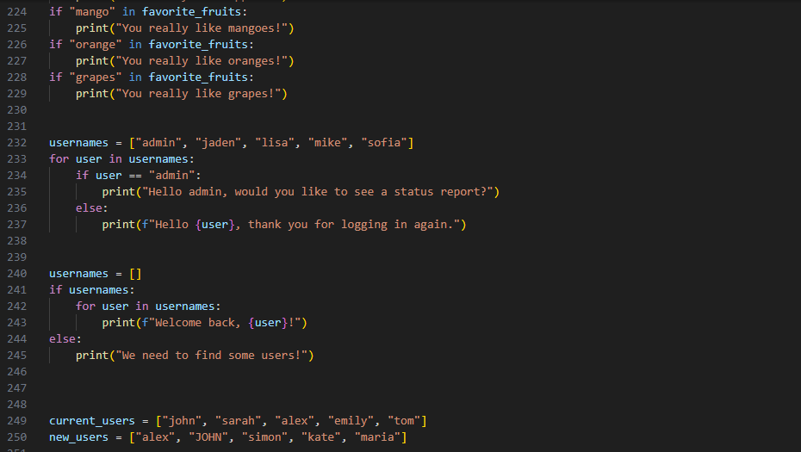

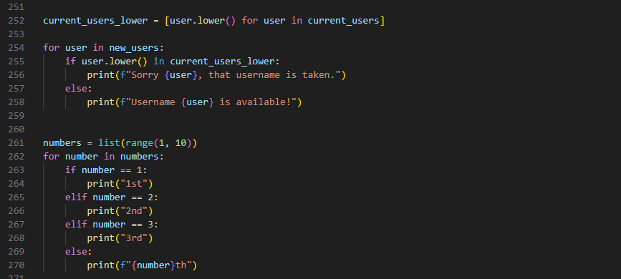

OUTPUTS:



